SIMATS ENGINEERING (SAVEETHA SCHOOL OF ENGINEERING)
Department of Computer Science and Engineering

ASSESSMENT TOOL 2 – SCENARIO BASED ASSESSMENT
Course Code: | CSA06 | Course Title: | Design and Analysis of Algorithms
CO Assessed: | CO2 – Manipulation (BL1, BL2, BL3) | Assessment: | Assessment Tool 2 – Scenario Based Assessment
Weightage: | 20% of CIA | Total Marks: | 100
CO2 Statement: | Apply Brute Force technique to solve sorting, searching, Closest-Pair and Convex-Hull problems (BL1, BL2, BL3)
Student Name: | R.NANDHINI | Reg. No.: | 192524355
Section / Batch: |  | Date:
Instructions to Students
- Answer the following question. Total Marks: 100.
- Carefully analyze the given scenario and identify the computational problem involved.
- Apply appropriate Brute Force techniques for sorting, searching, Closest-Pair, and Convex-Hull problems wherever applicable.
- Clearly justify the chosen solution approach with proper reasoning and analytical interpretation.
- Demonstrate decision-making skills by comparing possible solutions and selecting the most suitable approach.
- Use diagrams, stepwise illustrations, or algorithmic representations wherever necessary.
- Maintain clarity, logical organization, and proper technical presentation throughout the answers.

Question Type | Focus Area | Questions
Scenario Based Assessment | Analyze real-world scenarios and apply Brute Force techniques for sorting, searching, Closest-Pair, and Convex-Hull problems | Q1

SECTION A – SCENARIO BASED ASSESSMENT

1.A GIS-based flood monitoring system determines the outer boundary of flooded regions using
convex hull techniques.
a) Explain how brute-force convex hull is applied.
b) Analyze its computational complexity.
c) Discuss limitations when handling large datasets.

ANSWER:

Scenario:
A GIS-based flood monitoring system collects GPS coordinates of flooded locations. The Brute-Force Convex Hull algorithm is used to determine the outer boundary of the flooded area.
a) Execution of Brute-Force Convex Hull
Input Points:
A(1,1), B(2,5), C(5,4), D(6,2), E(3,2)
Execution Steps:
- Read all flood location points.
- Select every pair of points (A-B, A-C, A-D, ...).
- For each pair, check whether all remaining points lie on the same side of the line.
- If all points are on one side, that line is part of the convex hull.
- Repeat for all pairs.
- Connect the selected boundary points to form the outer boundary.
Output:
Convex Hull = A → B → C → D → A

b) Computational Complexity
- Best Case: O(n³)
- Average Case: O(n³)
- Worst Case: O(n³)
Reason:
The algorithm checks every pair of points and compares them with all other points.

c) Limitations for Large Datasets
- Requires many comparisons when the number of points increases.
- Execution time becomes very high for thousands of GPS points.
- Not suitable for real-time flood monitoring.
- Consumes more processing time.
- Faster algorithms such as Graham Scan or QuickHull are preferred for large datasets.

Final Result
The Brute-Force Convex Hull algorithm successfully identifies the outer boundary of flooded regions, but its O(n³) time complexity makes it inefficient for large GIS datasets.

CODE:
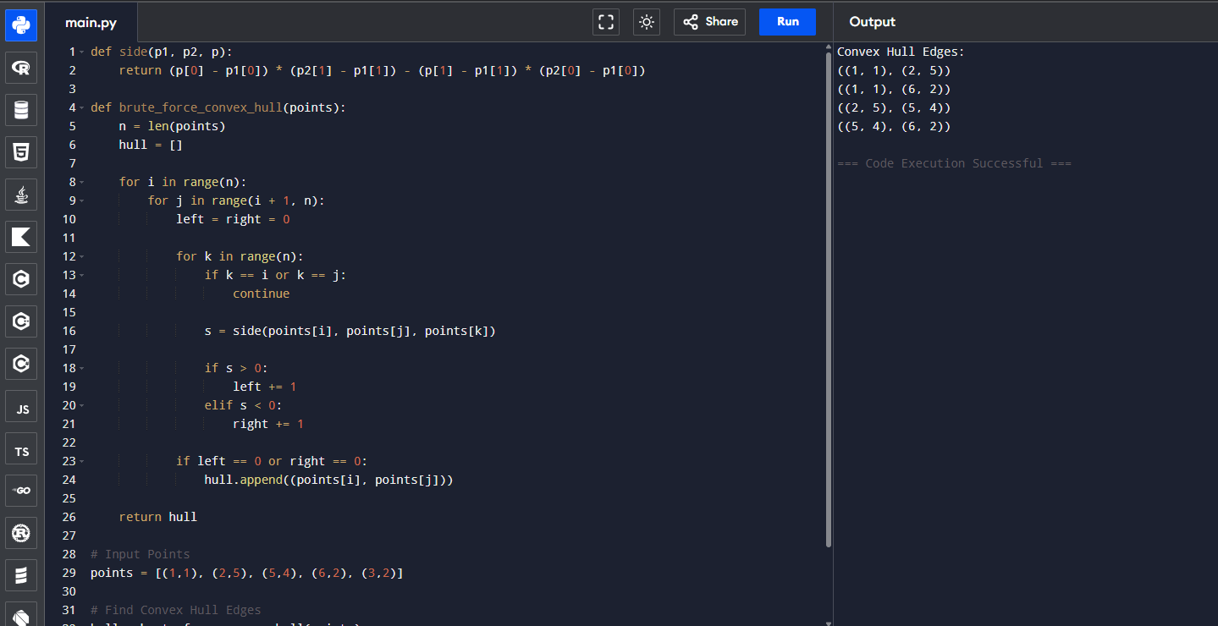

Code of Conduct
I (Name / Reg No) certify that this submission is my original work and that I have adhered to the guidelines specified for this assessment. I understand that any violation of academic integrity rules will result in disciplinary action.
Signature of the Student:

RUBRICS FOR CALCULATION

Criteria | Wt. | Level 4 – Exemplary | Level 3 – Proficient | Level 2 – Developing | Level 1 – Beginning
Problem Understanding & Context Analysis | 25% | Thoroughly understands the scenario with accurate interpretation of all requirements | Clearly understands the scenario with minor gaps | Basic understanding; some aspects of the scenario unclear | Poor understanding or misinterpretation of the scenario
Application of Concepts | 30% | Applies appropriate concepts effectively to solve complex real-world problems | Applies relevant concepts correctly with minor errors | Applies basic concepts but with limited accuracy | Fails to apply appropriate concepts
Analytical & Decision-Making Skills | 20% | Demonstrates strong analysis and selects optimal solutions with justification | Good analysis with reasonable solutions | Limited analysis; solutions lack justification | Poor or no analysis; incorrect decisions
Solution Design & Approach | 15% | Well-structured, innovative, and feasible solution approach | Logical and structured solution with minor gaps | Basic solution with limited structure or feasibility | Unclear or incorrect solution approach
Clarity, Justification & Presentation | 10% | Clear, well-justified explanation with strong reasoning | Clear explanation with some justification | Limited clarity and weak justification | Poorly explained with no justification

Marks Evaluation:
Criteria | Wt. | Level 4 – Exemplary | Level 3 – Proficient | Level 2 – Developing | Level 1 – Beginning
Problem Understanding & Context Analysis | 25%
Application of Concepts | 30%
Analytical & Decision-Making Skills | 20%
Solution Design & Approach | 15%
Clarity, Justification & Presentation | 10%
Total Marks (100):

Faculty In-charge | Course Coordinator | Head of Department
Name: | Name: | Name:
Signature: | Signature: | Signature:
Date: | Date: | Date:

